|  |
| --- |
| **EMBEDDED SYSTEM LABORATORY** |
| **LAB 2**  **Nguyễn Gia Cát Tường ITITIU21117** |

### I. LAB OBJECTIVES

### - In this Lab students will learn about ARM-CORTEX M3 (LPC1768) Microcontroller.

### - This Lab experiments are intended to implement basic Timer of ARM-CORTEX M3 Microcotroller to pheriperal devices in MB1700 Kit and write C code programming to control these devices.

### II. PRE-LAB : Timer Register Review

### 

0<<1, 1<<2, 2<<22, 3<<23

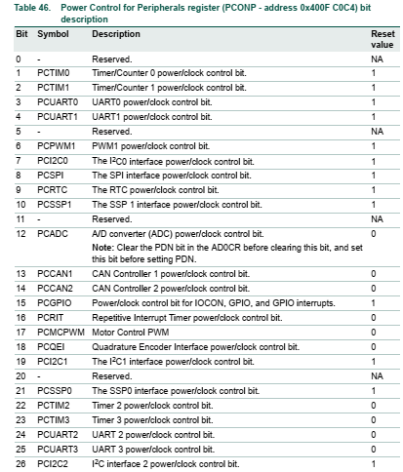

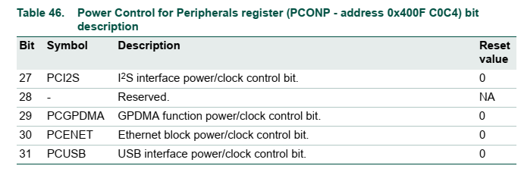

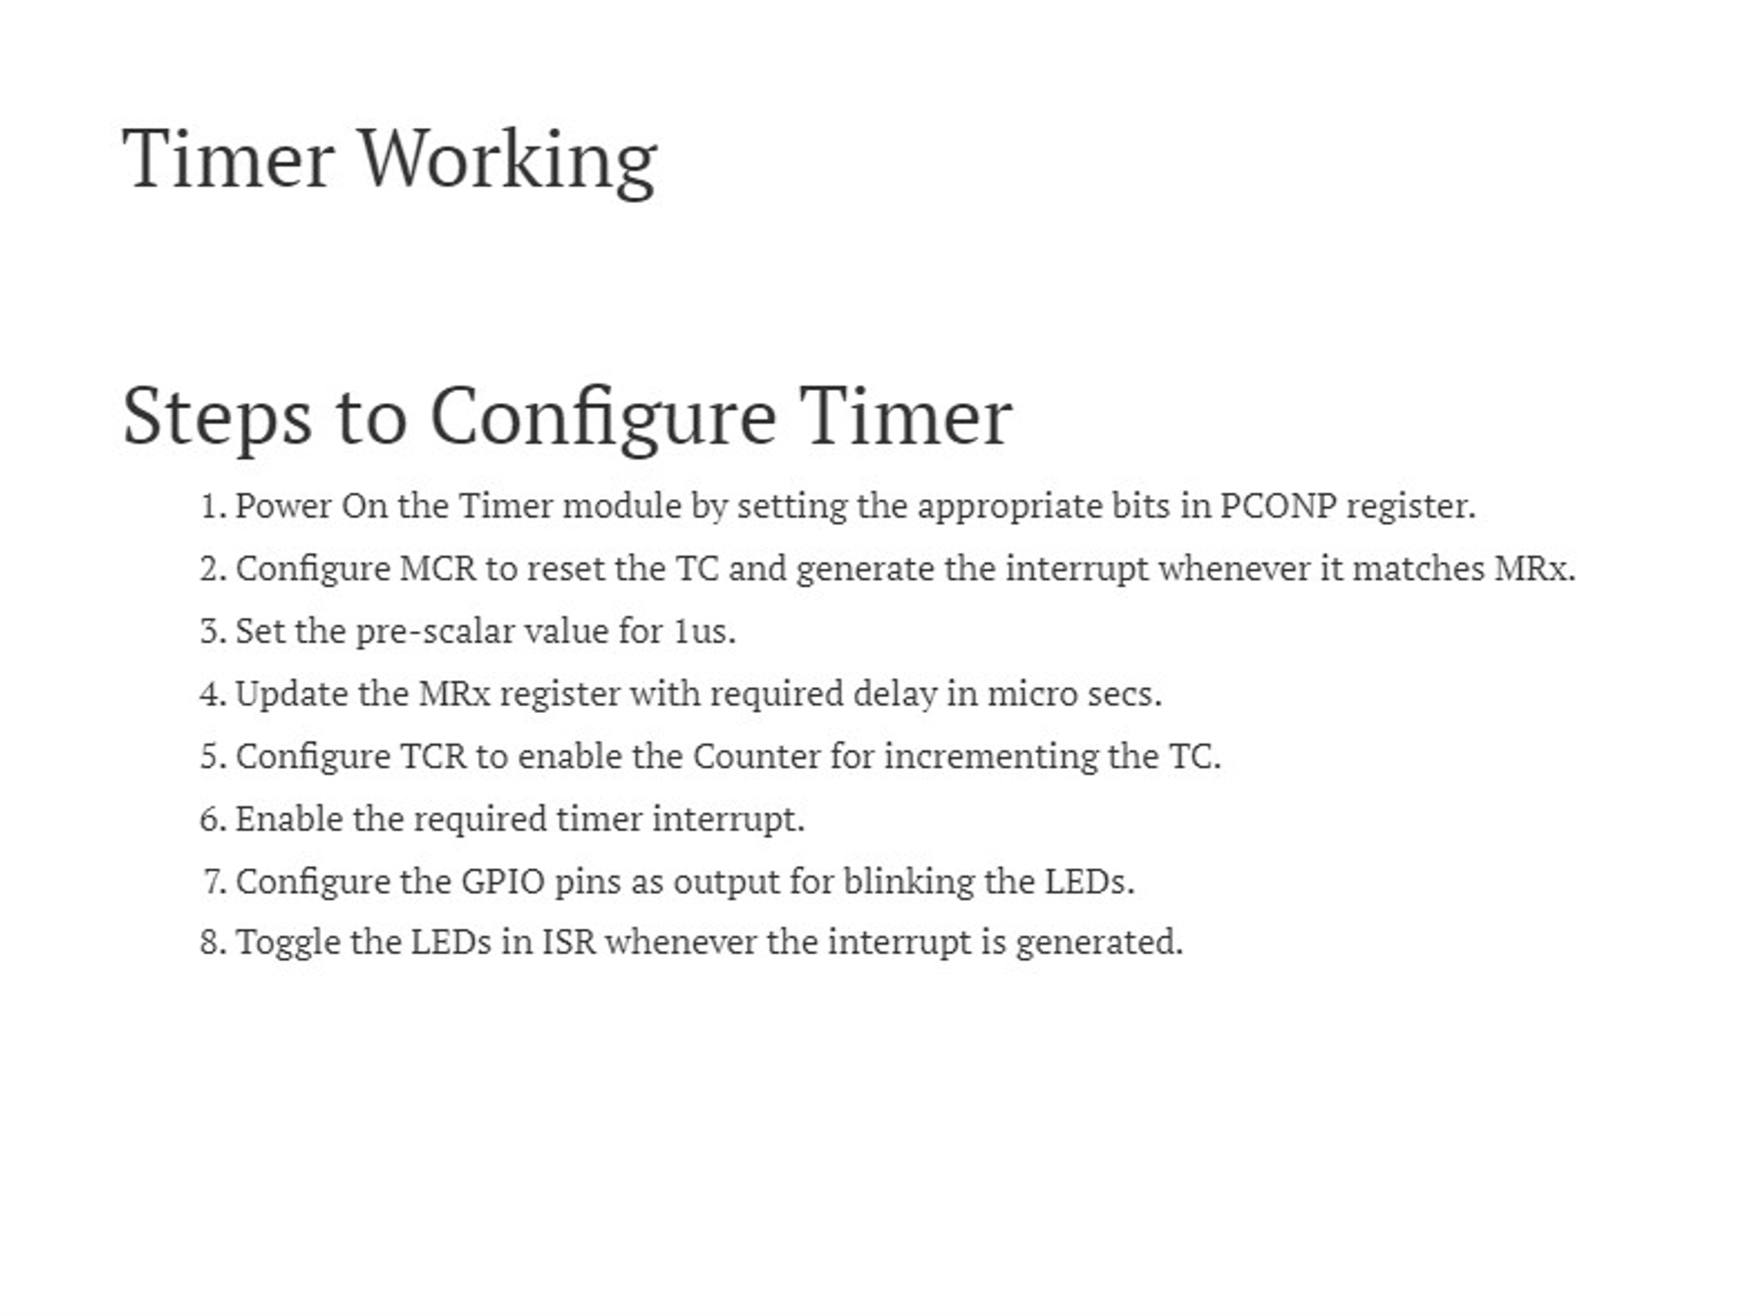

### III. LAB PROCERUCE

### The LPC1768 Microconttroler KIT using 100MHz system clock.

### III.1 Lab Experiment 1 : Write the code to turn on and turn off a led which is connected to P2.2 GPIO port pin with the time delay 1 second.using Timer0 polling method. Using PCLK=System Clock/2 mode, with period 1ms.

### III.2 Lab Experiment 2 : Write the code to turn on and turn off a led which is connected to P2.3 GPIO port pin with the time delay 2 second.using Timer1 polling method. Using PCLK=System Clock/4 mode with period 1ms.

### III.3 Lab Experiment 3: Write the code to turn on and turn off a led which is connected to P2.4 GPIO port pin with the time delay 3 second.using Timer2 polling method. . Using PCLK=System Clock/8 mode with period 1ms.

### III.4 Lab Experiment 4: Write the code to turn on and turn off a led which is connected to P2.5 GPIO port pin with the time delay 4 second.using Timer3 polling method. . Using PCLK=System Clock/4 mode with period 4ms.

### III.5 Lab Experiment 5 : Write the code to turn on and turn off a led which is connected to P2.2 GPIO port pin with the time delay 1 second.using Timer0 Interupt method. Using PCLK=System Clock/2 mode, with period 1ms.

### III.6 Lab Experiment 6 : Write the code to turn on and turn off a led which is connected to P2.3 GPIO port pin with the time delay 2 second.using Timer1 Interupt method. Using PCLK=System Clock/4 mode with period 1ms.

### III.7 Lab Experiment 7: Write the code to turn on and turn off a led which is connected to P2.4 GPIO port pin with the time delay 3 second.using Timer2 Interupt method. . Using PCLK=System Clock/8 mode with period 1ms.

### III.8 Lab Experiment 8: Write the code to turn on and turn off a led which is connected to P2.5 GPIO port pin with the time delay 4 second.using Timer3 Interupt method. . Using PCLK=System Clock/4 mode with period 4ms.

### III.9 Lab Experiment 9: Write the code to control 4 leds which is connected to P2.2, P2.3, P2.4 P2.5 GPIO port pins using Timer Interrupt methods. Using PCLK=System Clock/4 mode with period 1ms.

### Led P2.2 will turn on-off with 1 second interval using Timer0

### Led P2.3 will turn on-off with 2 second interval using Timer1

### Led P2.3 will turn on-off with 4 second interval using Timer2

### Led P2.4 will turn on-off with 8 second interval using Timer3.

### III.10 Lab Experiment 10: Write a C program to control 8 leds in the KIT with 4 Led lighting modes (Mode 1: 8 lights gradually turn on, Mode 2: 8 lights gradually turn on, Mode 3: 8 chasing lights from left to right, Mode 4: 8 chasing lights from right to left) using Timer0 Interrupt.

### III.11 Lab Experiment 11: Write a program to interface LPC1768 GPIO port pin using Keil C to scan P1.23 pin, P2.4, P25 and P1.26 joystick buttons and change the Led controlling mode in Lab experiment 7 with an appropritate mode. The initial default LED controlling mode is Mode 1.

